**Name : Aman Barthria**

**Email :** [**piyushsaxena7272@gmail.com**](mailto:piyushsaxena7272@gmail.com)

**Mob : 8979128688**

**Batch : DA-202411-1**

**Course : Data Analytics + Python**

**Institution Name : SkilloVilla**

**Contents:- Page No.**

Tast 1 - Top Categories by total Price: 2

Task 2 - Delayed Orders Analysis: 3

Task 3 - Monthly Comparison of Delayed and On-Time Orders: 4-5

Task 4 - Payment Method Analysis: 6

Task 5 - Product Rating Analysis 7

Task 6 – State-wise Sales Analysis 8

Task 7. Seasonal Sales Patterns 9

Task 8 -Revenue Analysis 10

**Task 1. Top Categories by total Price:** Identify and visually represent the top 10 product categories by total sales

**Visualization:**

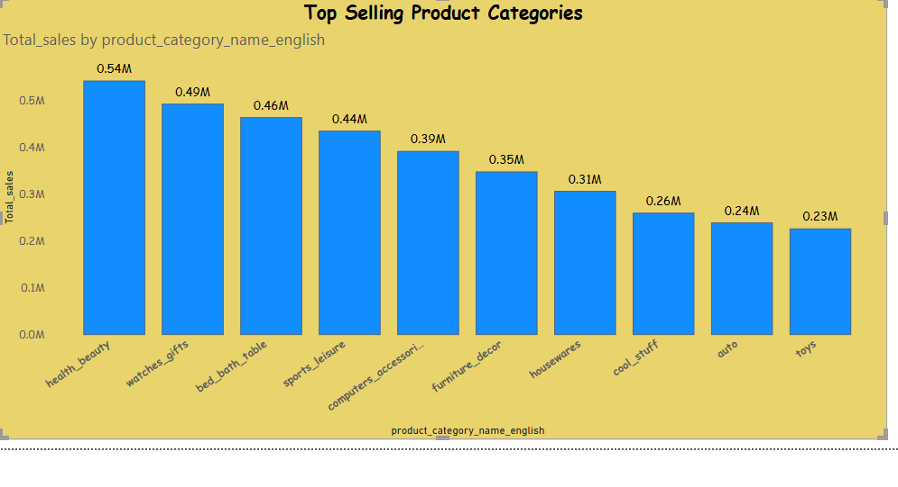**Explanation:** This bar chart represents the top 10 product categories based on total sales. The data was grouped by category, and the total price was summed for each group. Categories are sorted in descending order. The top-performing categories highlight where the store earns the most revenue.

**Task 2. Delayed Orders Analysis:** Determine the number of delayed orders in each category. An order is considered delayed if the actual delivery date is later than the estimated delivery date.

**Visualization**

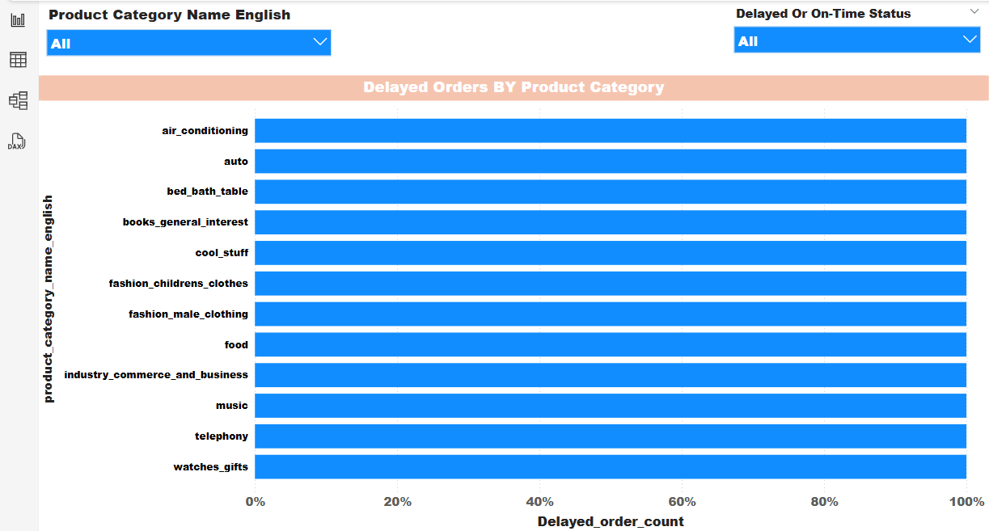 **Explanation:**

This chart shows the count of delayed orders by product category. A delayed order is defined as one where the actual delivery date exceeded the estimated delivery date. The chart helps identify which product categories face frequent delivery issues.

**Task 3: Monthly Comparison of Delayed and On-Time Orders:**

**Create a dynamic visual that compares the number of delayed orders to the number of orders received earlier for each month. Utilize the drill through cross-report feature to provide a detailed analysis with delivery details chart.**

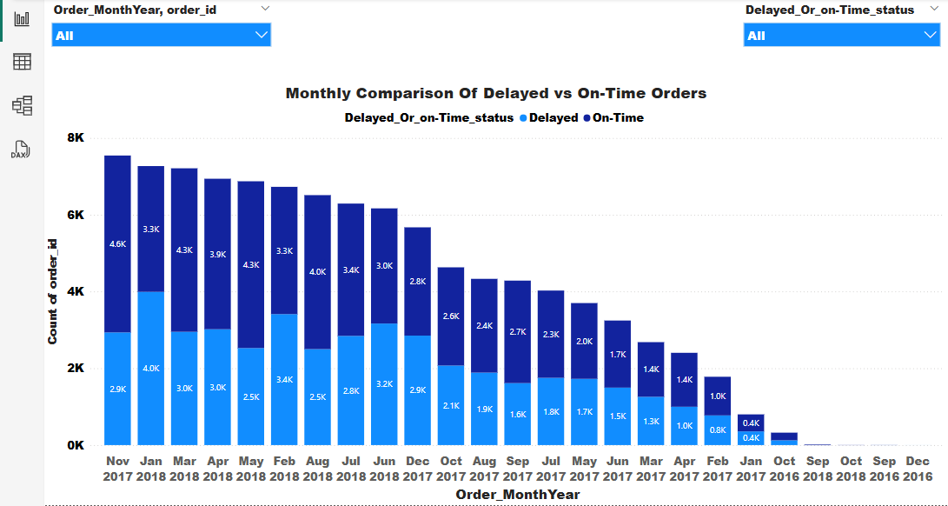 **Visualization:**

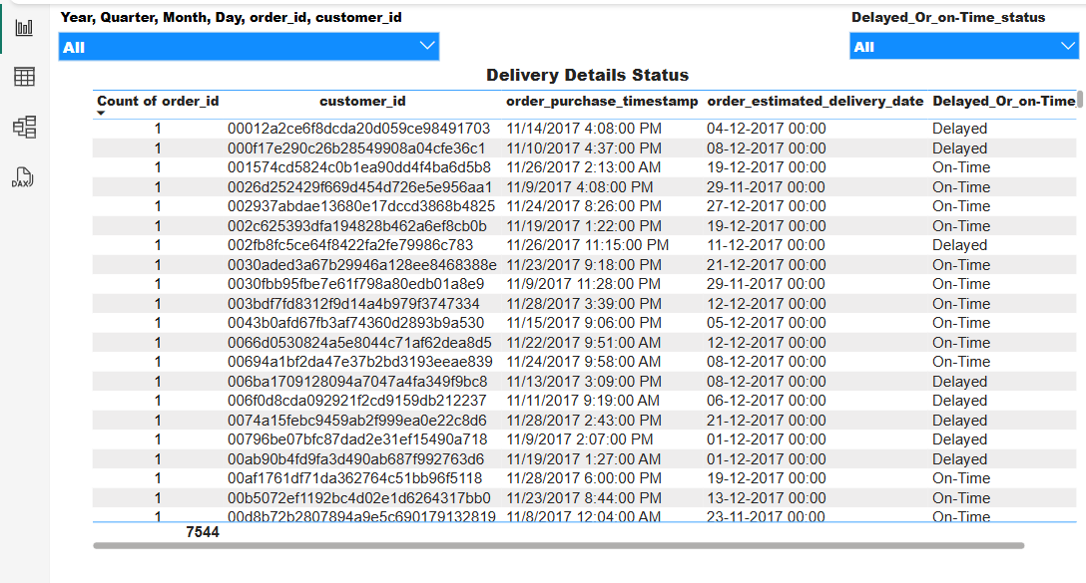 **Explanation:**

The stacked column chart compares delayed vs. on-time orders per month. Drill through allows detailed monthly analysis. The trend reveals periods with increased delays, useful for improving logistics.

**Task 4. Payment Method Analysis**

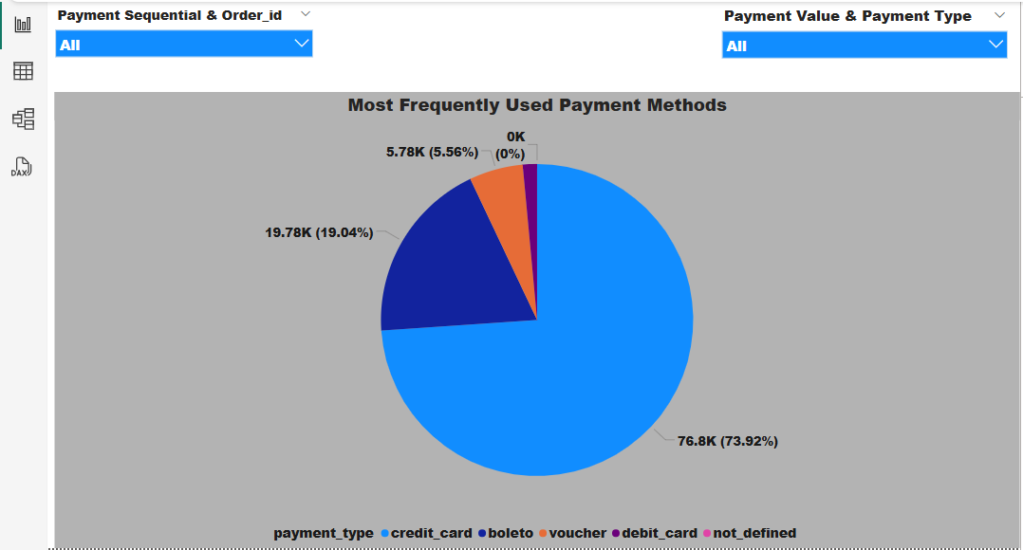**Analyse the most frequently used payment methods by customers using a visually appealing representation. Visualization:**

**Explanation:**

This pie chart displays the share of different payment methods used by customers. The visual quickly shows which methods are preferred, such as Credit Cards or Digital Wallets, aiding payment strategy decisions.

**Task5. Product Rating Analysis**

**Determine the top 10 highest-rated and the bottom 10 lowest-rated products using a bar or column chart.**

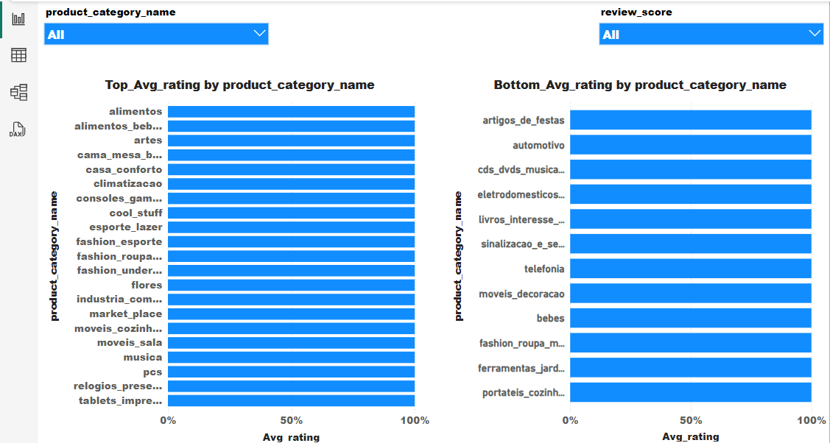 **Visualization:**

**Explanation:**

Two bar charts highlight products with the best and worst customer ratings. This helps identify top performers and products needing quality improvement based on customer feedback.

**Task6. State-wise Sales Analysis**

**Identify and visually represent states with high and low sales.**

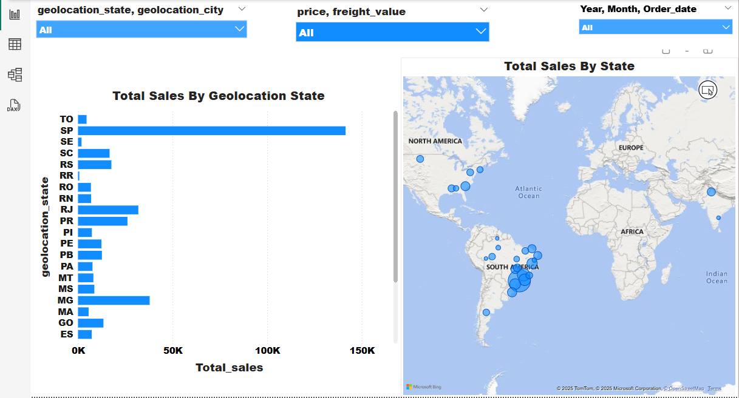 **Visualization:**

**Explanation:**

The map or column chart displays total sales by state. It highlights regional performance,showing where the store performs well and where growth opportunities exist.

**Task7. Seasonal Sales Patterns**

**Investigate and visualize any seasonal patterns (Quarterly) or trends in sales data over the course of the year.**

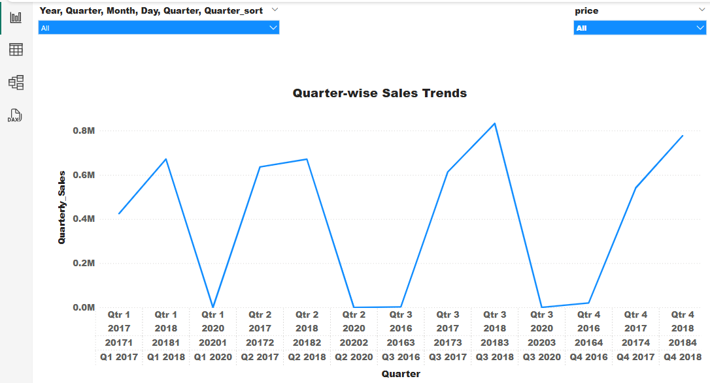 **Visualization:**

**Explanation:**

**The line chart shows quarterly sales trends. Peaks indicate strong seasons (e.g., Q4 holiday season), while dips may highlight off-seasons. This analysis helps plan inventory and marketing.**

**Task8. Revenue Analysis**

**Determine the total revenue generated by ShopNest Store and analyze how it changes over time (Yearly).**

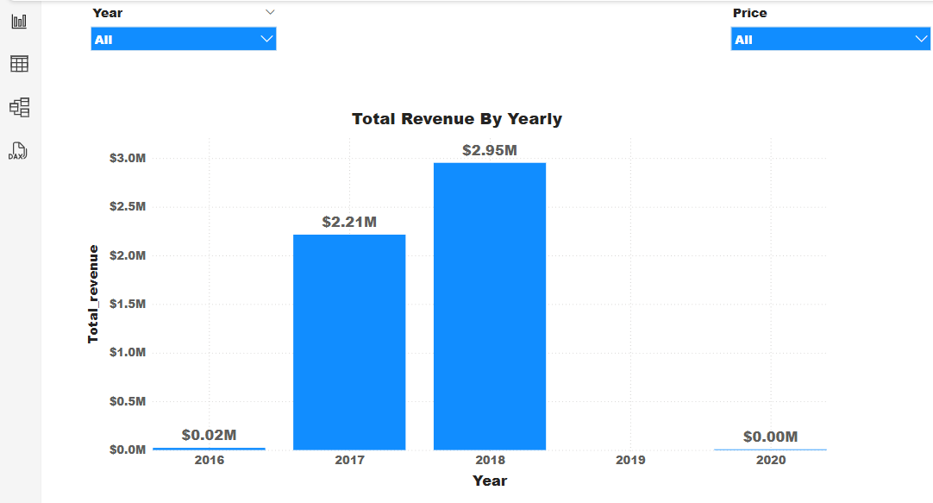 **Visualization:**

**Explanation:**

The column or line chart presents total yearly revenue. It reveals growth trends and helps measure performance year-over-year. Key periods of growth or decline are identified for further analysis.